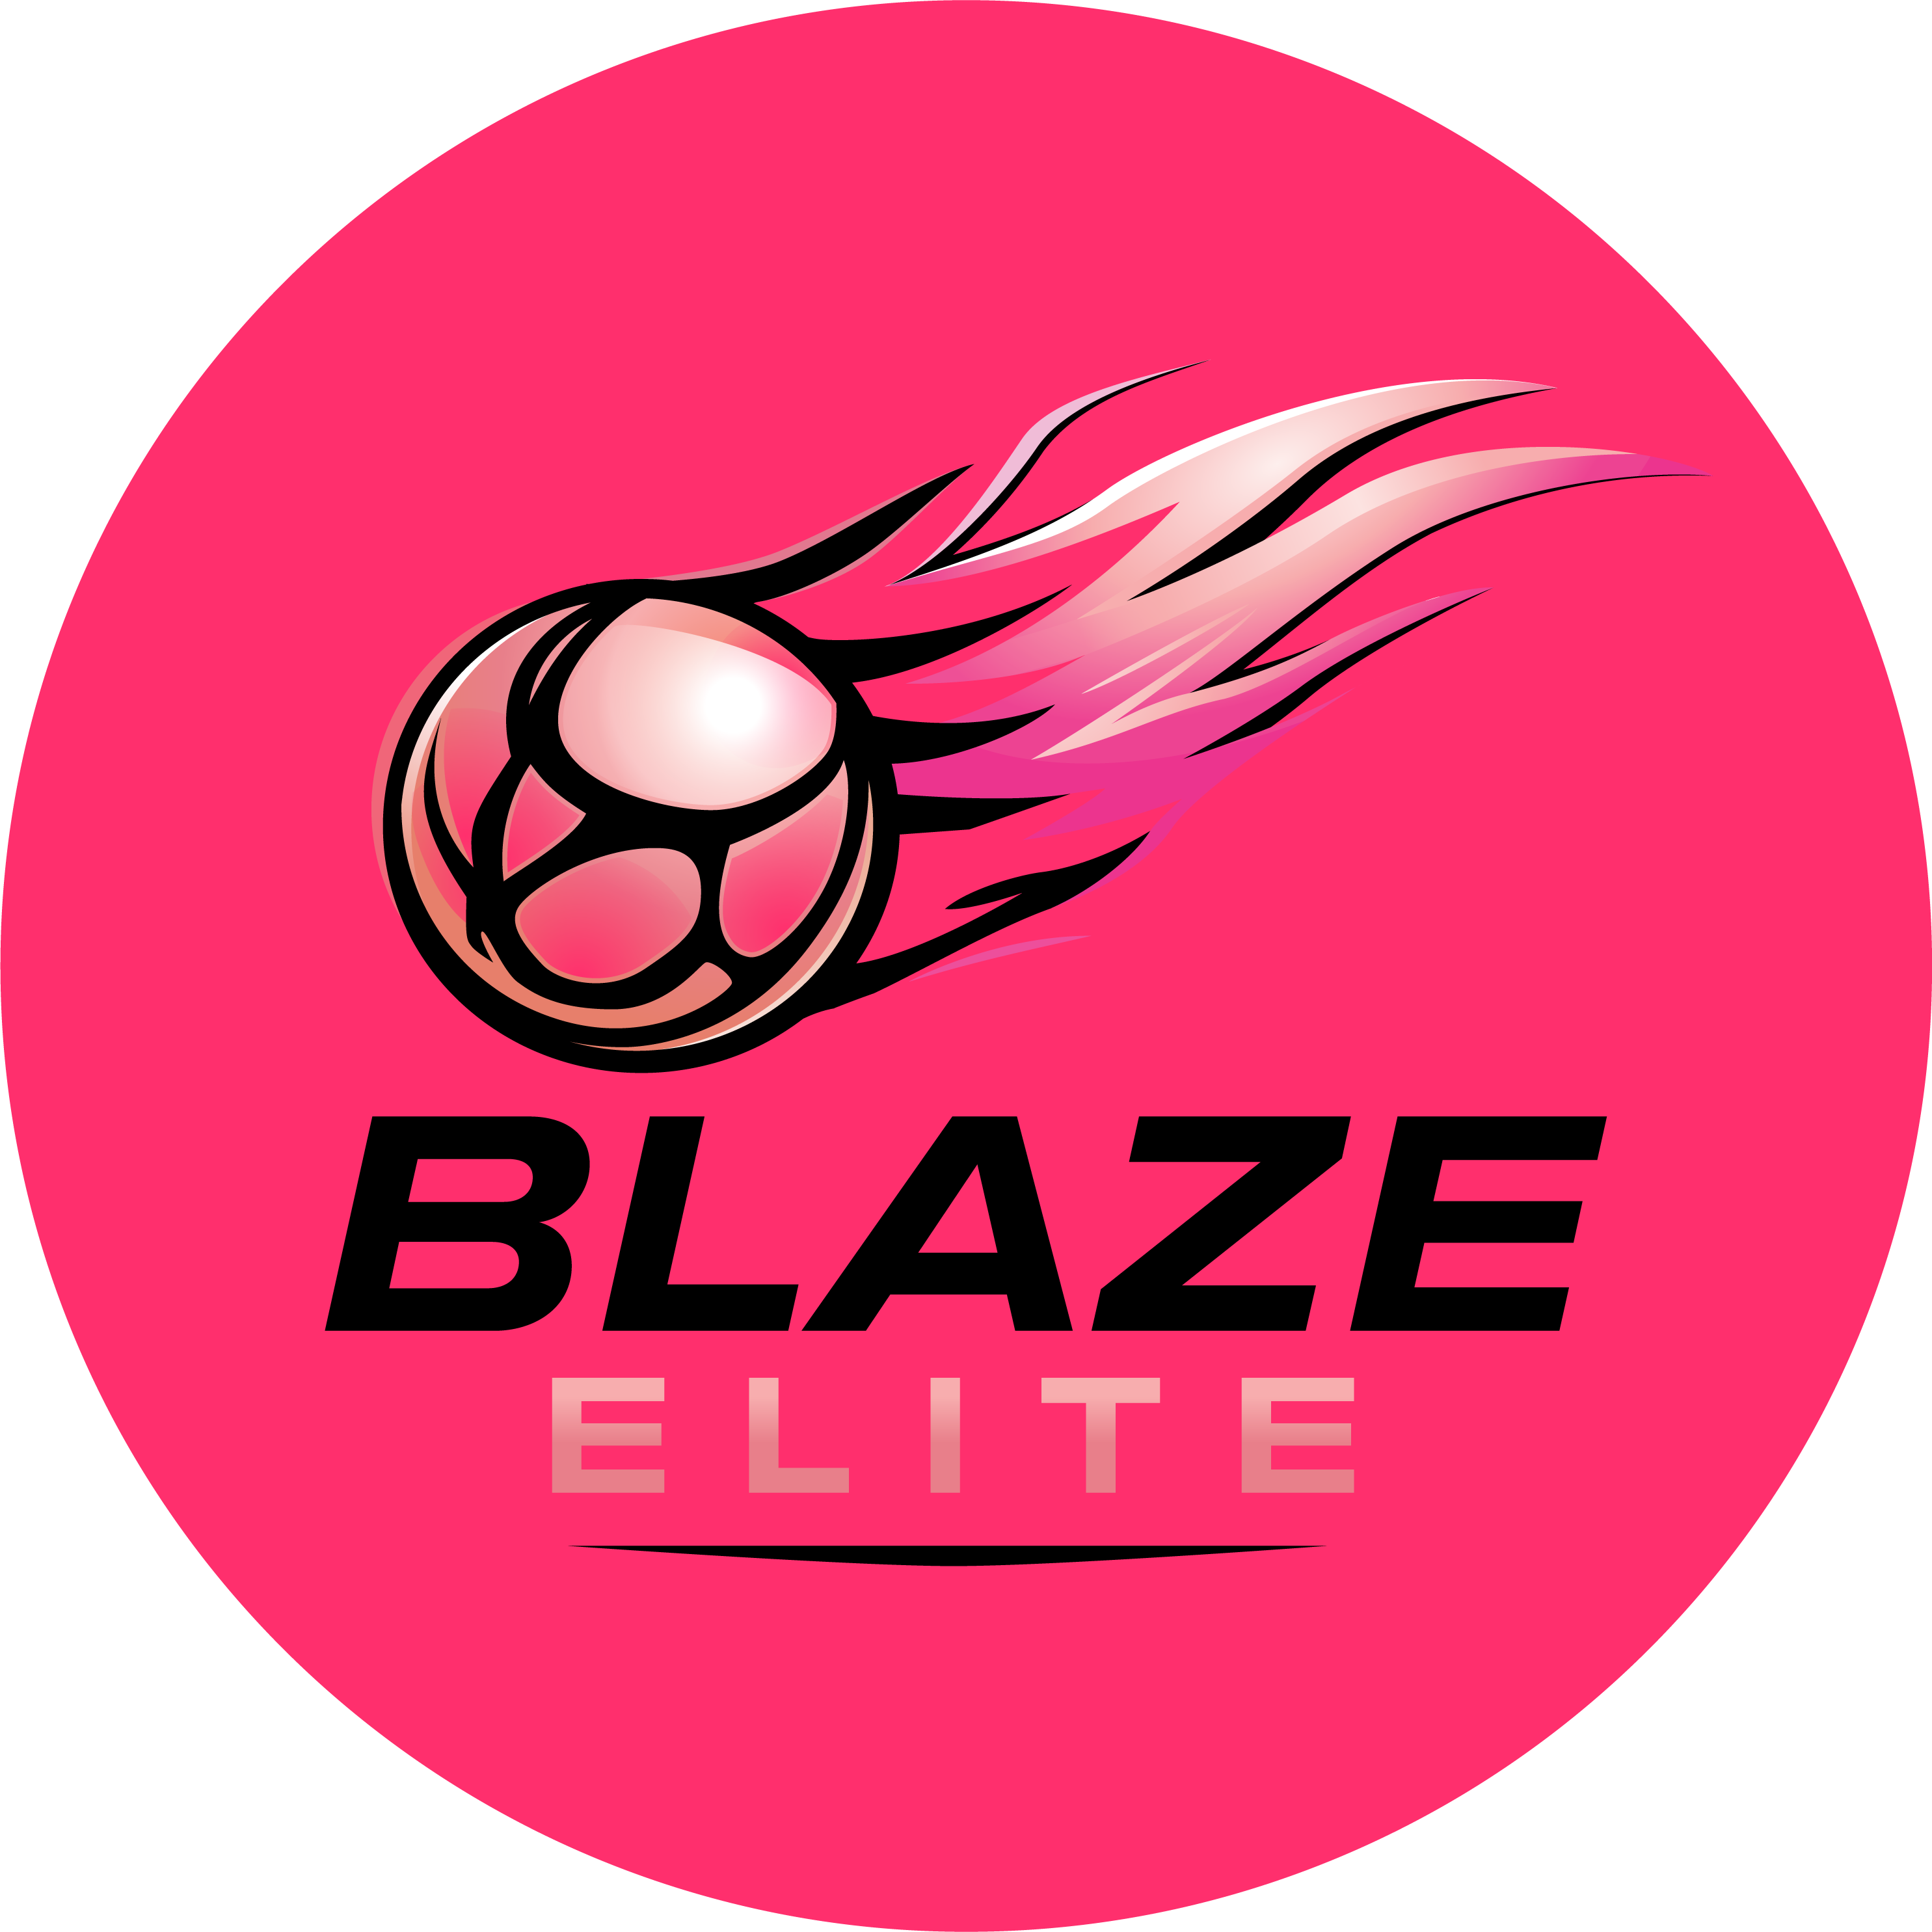

Parent / Guardian Code of Conduct
Blaze Elite Netball Club
Blaze Elite operates within a defined performance framework led solely by the Coaching Team. This Code sets out how parents and guardians support that environment.

1. Sideline Conduct & Coaching Boundaries
- Parents must not provide sideline coaching or tactical instruction during fixtures or training.
- Contradictory messaging can confuse athletes and undermine the coaching process.
- Tactical direction and performance feedback are the responsibility of the Coaching Team only.
- Publicly, and with grace, accept the judgment of officials, coaches and club administration.
- Discourage unfair play and dissent towards officials, and set a good example by recognising fair play and congratulating all athletes' performances, not just your own child's.
- Respect viewing regulations at matches, and accept that courtside viewing is not permitted at training.

2. Athlete Confidence & Messaging
- Parents must not speculate on selection or court time.
- Parents must not pre-empt coaching decisions.
- Help your athlete recognise good performance, not just results, and never punish or belittle them for losing or making mistakes.
- Never force your athlete to take part — support their involvement and help them enjoy their sport.
- Parents should reinforce resilience, preparation and team-first standards.
What is said to an athlete away from the court directly impacts their confidence and performance.

3. Contacting Coaches / Team Managers
- All communication regarding training, fixtures and logistics should be directed in the first instance via the squad's usual communication channel (e.g. Spond) and/or to the squad Team Manager, as appropriate.
- Coaching queries relating to player development should be raised respectfully and at an appropriate time with the Head Coach.
- Team Managers assist with the administration of their squad and are not involved in selection decisions; please direct any selection query to the Head Coach instead.
- Reply promptly to any communication from the club, and check the club's usual channels regularly for up-to-date information.
- Pay fees promptly, and thank your coaches, officials and volunteers rather than interfering with their decisions.

4. Maintaining a Positive Environment
- Do not share negative commentary about coaching decisions, team selection or feedback with other parents, athletes, or in messaging groups. Raise any concerns directly and privately with the Head Coach instead (see Section 3).
- Avoid discussing coaching decisions, selection or feedback in front of athletes, including your own — inconsistent messaging from parents undermines coaching and can confuse athletes.
- Negative commentary, whether at training, matches, tournaments or in messaging groups, damages the environment for the whole squad and will not be tolerated.
- Please promote this Code of Conduct to other parents, guardians and supporters.

5. Photography, Video & Social Media
- Do not take photographs or video of training or matches without the club's permission — see the Photography & Video Policy for the process.
- Do not post negative, disparaging or inflammatory comments about Blaze Elite, its coaches, committee members, officials, or other athletes and families, on social media, messaging groups, or any other public platform.
- Please use social media connected to the club for practical, club-related matters only.

6. Respect & Inclusion
- Treat coaches, committee members, officials, other athletes and families with respect, regardless of background.
- Discriminatory behaviour or language of any kind, on or off the court, will not be tolerated.

7. Safeguarding
- Be aware of Blaze Elite's Safeguarding & Child Protection Policy, and report any concerns to the Safeguarding & Welfare Officer.

